Ideation Phase
Define the Problem Statements

Date | 18 February 2026
Team ID | LTVIP2026TMIDS65799
Project Name | Online Payments Fraud Detection using Machine Learning
Maximum Marks | 2 Marks

Customer Problem Statement Template:
Create a problem statement to understand your customer's point of view. The Customer Problem Statement template helps you focus on what matters to create experiences people will love.
A well-articulated customer problem statement allows you and your team to find the ideal solution for the challenges your customers face. Throughout the process, you’ll also be able to empathize with your customers, which helps you better understand how they perceive your product or service.

Reference: https://miro.com/templates/customer-problem-statement/
Example:
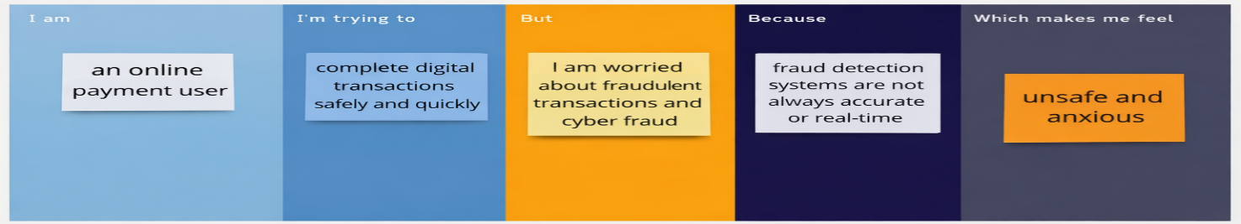

Problem Statement (PS) | I am (Customer) | I’m trying to | But | Because | Which makes me feel
PS-1 | an online payment user | complete digital transactions safely and quickly | I am worried about fradulent transactions and cyber fraud | fraud detection systems are not always accurate or real-time | unsafe and anxious while making online payments
PS-2 | a bank or financial institution | protect customers from fraudulent online payment transactions | traditional rule-based systems fail to detect complex fraud patterns | fraudsters continuously develop new techniques | concerned about financial loss and customer trust

